Colombian Coffee Value Chain and Pricing: Smallholders, Risk and the Peace Process

Technical report with charts, tables and equations. Final section connects with the Capstone Project “Pactone”.

# Executive Summary

Colombia’s coffee sector involves over 540,000 farming families—mostly smallholders operating under 5 hectares—coordinated through a unique institutional framework led by the National Federation of Coffee Growers (FNC). While the country sustains world-class quality in washed Arabica, producers’ incomes are highly exposed to price volatility. The internal price paid at farmgate is primarily driven by the ICE ‘C’ futures price and the COP/USD exchange rate. This report maps the value chain, details the internal pricing equations, offers sensitivity analysis, and examines the effects of the armed conflict and the subsequent peace process on coffee regions. It concludes by linking these insights to the Capstone Project , which uses econometrics and machine learning to forecast future prices so smallholders can time sales, hedge risks, and improve margins.

# 1. Introduction

Colombian coffee is more than a crop: it is a rural socio-economic system. The sector’s reputation is built on selective picking, careful wet processing and drying, and a governance framework that supports quality and traceability. However, rising input costs, climate variability, exchange-rate swings, and the legacy of armed conflict challenge resilience and long-term investment. This report provides an end-to-end view—from farm to consumer—with an emphasis on how internal prices are formed and how they react to international variables.

# 2. Value Chain and Institutional Actors

The Colombian value chain comprises farmers selling parchment coffee to coops or local buyers; hulling plants turning parchment into export-grade green coffee; exporters managing contracts and logistics; and roasters/brands defining sensory profiles and go-to-market. FNC coordinates purchasing and posts the internal reference price; Cenicafé leads R&D; ICA issues phytosanitary certificates; and DIAN/MinCIT oversee customs and trade.

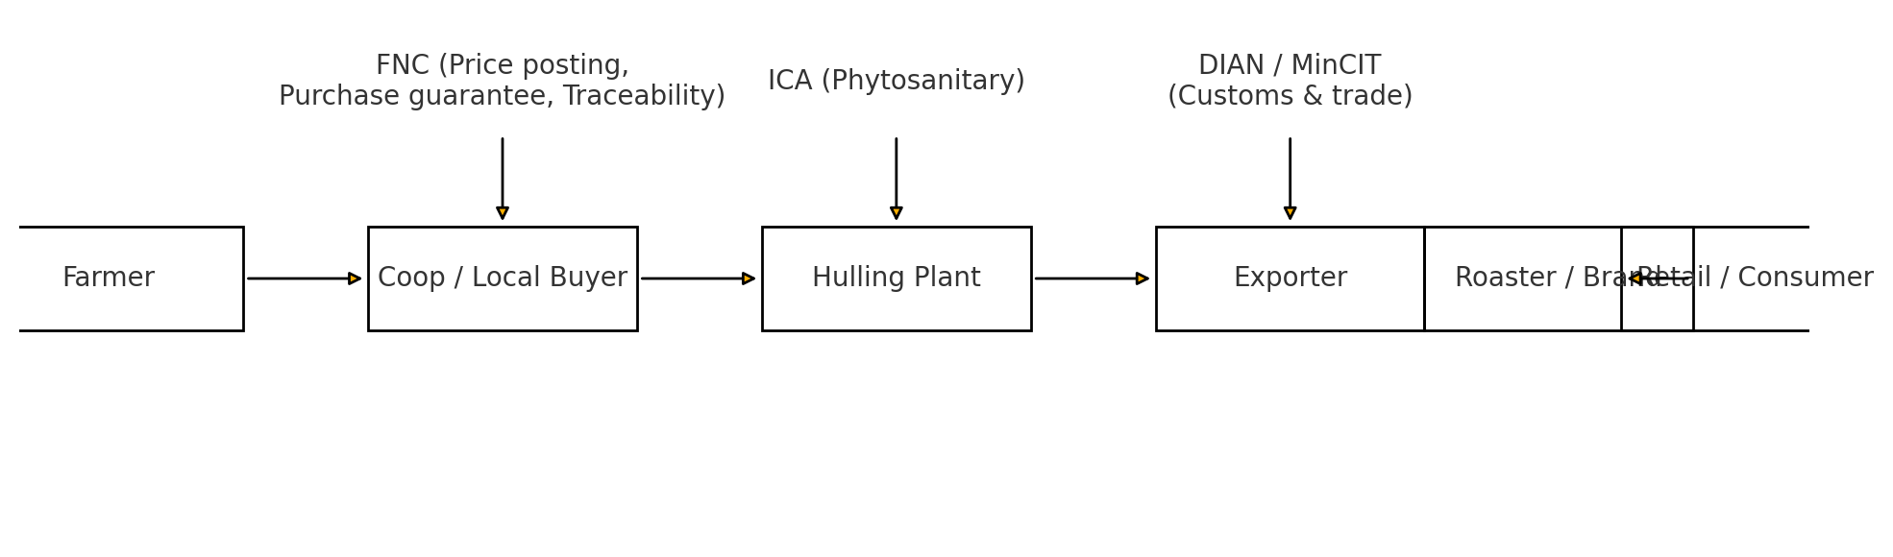

Figure 1. Flow diagram of the Colombian coffee value chain and institutional actors.

Reading guide: each box is a stakeholder; arrows indicate physical and documentary flows. Top labels list regulators/support entities. Farmer→Coop involves weighing and quality checks; Coop→Hulling defines yield and shrink; Hulling→Exporter consolidates quality and documentation; Exporter→Roaster closes contracts (FOB/CIF) and logistics; Roaster→Retail converts the bean into consumer goods.

|  |  |  |
| --- | --- | --- |
| Link | Description | Agents |
| Farmer | Selective harvest, wet milling, drying to 10–11% moisture. | Small/medium growers. |
| Coop / Local Buyer | Purchasing, aggregation, QC, financing services. | Coops affiliated to FNC; private buyers. |
| Hulling Plant | Hulling, size/density sorting, defect control, homogenization. | Almacafé; private plants. |
| Exporter | International contracts, documentation, logistics, risk management. | FNC and private exporters. |
| Roaster / Brand | Roasting, sensory profile, packaging, commercialization. | Domestic & international roasters. |
| Retail / Consumer | Retail sale and final consumption. | Grocery, cafés, e-commerce. |

Table 1. Main links in the value chain and associated responsibilities.

# 3. Producer System and the Role of Smallholders

Colombian production is dominated by family-run smallholdings (≤ 5 ha). Atomization enables selective picking and tighter process control, which support quality and traceability. Coops provide crucial services—credit, inputs, technical assistance, aggregation, market access—while smallholders sustain rural employment and preserve sustainable practices. Their challenges include price/FX volatility, limited working capital, high input costs and sanitary pressures, and climate risks.

|  |  |  |
| --- | --- | --- |
| Farm size | Share of growers | Share of production (approx.) |
| Small (≤ 5 ha) | 90–95% | 70–80% |
| Medium (5–20 ha) | 4–8% | 15–20% |
| Large (> 20 ha) | 1–2% | 5–10% |

Table 2. Producer structure (illustrative ranges for explanatory purposes).

# 4. Internal Price Formation and Equations (FNC)

The farmgate internal price is posted daily. In simplified form, it depends on the ICE ‘C’ price (USD/lb), the COP/USD exchange rate, origin/quality differentials and premiums, and a conversion factor that maps USD/lb to COP per 125‑kg load of parchment coffee.

Equation (1):

*Pinternal (COP/load)* = [ (*PICE*) + Differential + QualityPremium ] × TRM × *Kconv*

Where:

• Pₑₒₐ (ICE) is the ICE ‘C’ futures price in USD per pound (USD/lb).

• Differential: origin/quality differential (USD/lb); typically positive for washed milds.

• QualityPremium: specialty/verification premiums (USD/lb) when applicable.

• TRM: COP/USD exchange rate.

• Kconv: conversion factor from USD/lb to COP per 125‑kg load, incorporating lb→kg, kg→load and hulling yield.

Equation (2):

*Kconv* = ≈ (0.453592 kg/lb) × (1 load / 125 kg) × (kg parchment / kg green)*−1* × moisture/shrink adjustments

Interpretation: the (ICE × TRM) product dominates internal price variation; differentials/premiums add value; Kconv captures hulling yield and moisture/shrink adjustments.

Illustrative calculation (example values):

|  |  |  |
| --- | --- | --- |
| Variable | Value | Notes |
| ICE ‘C’ price | 1.80 USD/lb | International reference |
| Differential + Premium | +0.50 USD/lb | Origin/quality and specialty |
| FX (TRM) | 4,200 COP/USD | Exchange rate |
| Kconv | conversion factor | Yield & moisture |
| Internal price | ≈ COP 2.94 M per load | Illustrative outcome |

Table 3. Internal price calculation example. A ±10% change in ICE or FX nearly scales the outcome.

# 5. Elasticity and Sensitivity of Internal Price

On average, around 65% of internal price variation is explained by the ICE ‘C’ price, ~30% by the COP/USD exchange rate, and the remaining share by differentials/premiums and yield. The bar chart below summarizes approximate contributions.

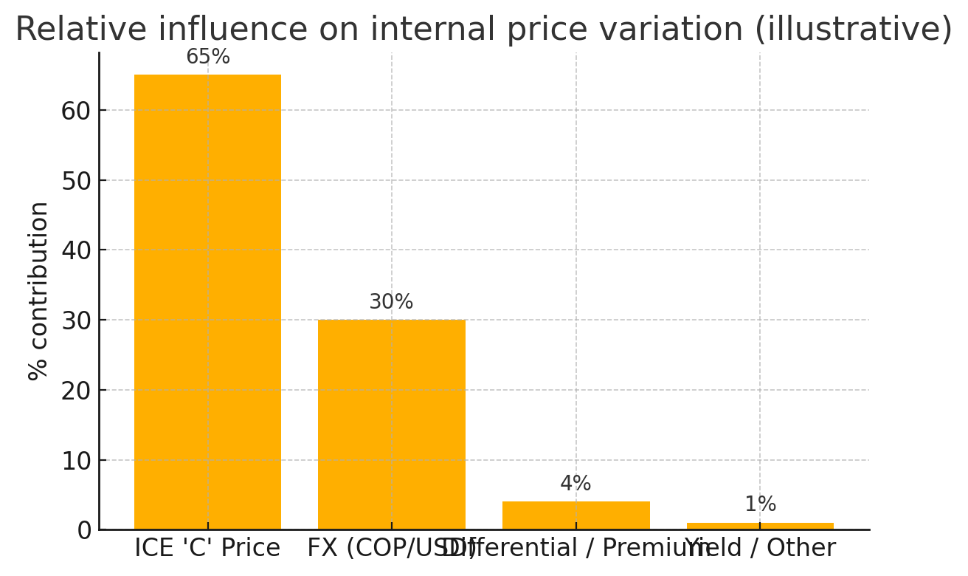

Figure 2. Relative contribution to internal price variation (illustrative).

Axes: X-axis lists components; Y-axis shows approximate percentage contribution. Reading: ICE and FX dominate pricing dynamics; premiums and yield provide smaller effects.

Scenario impacts (illustrative):

|  |  |  |
| --- | --- | --- |
| Scenario | Variable change | Expected effect on internal price |
| ICE +10% | +10% | ≈ +9–10% |
| FX +10% | +10% | ≈ +9–10% |
| ICE + FX +10% | +10% and +10% | ≈ +20% |
| Quality premium +0.20 USD/lb | +0.20 USD/lb | ≈ +2–4% |

Table 4. Sensitivity of internal price to key drivers (reference values).

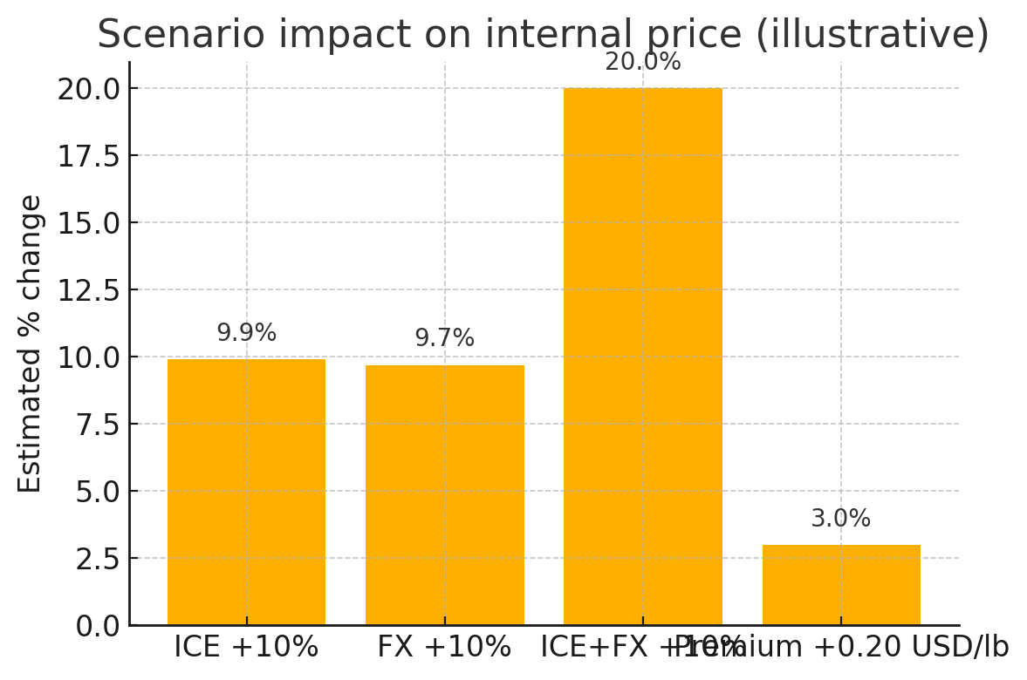

Figure 3. Scenario impact on internal price (illustrative).

Axes: X-axis lists variation scenarios; Y-axis shows estimated price change. Interpretation: combined ICE and FX effects are nearly additive; premium changes contribute modestly.

# 6. National Production and Seasonality (Table only)

Harvest calendars vary by cordillera and altitude, shaping working-capital needs and parchment availability. Below is a reference table. At the user’s request, no region-harvest graph is included.

|  |  |  |  |
| --- | --- | --- | --- |
| Region / Altitude | Main harvest | Fly crop | Quality notes |
| Cauca / Nariño (high) | Apr–Jul | Oct–Dec | Bright acidity, high sweetness |
| Huila / Tolima (mid-high) | May–Aug | Nov–Jan | Balanced, consistent |
| Antioquia / Coffee Axis | Sep–Dec | Mar–May | Classic profiles, medium body |
| Sierra Nevada / Santander | Sep–Jan | Mar–May | Microclimate-differentiated profiles |

Table 5. Seasonality and profiles by region (reference scheme).

# 7. Armed Conflict and the Peace Process: Effects on Coffee

The armed conflict heavily impacted coffee regions through displacement of rural families, mobility restrictions and security costs, lower investment in production and transport infrastructure, and weakened local associations. These factors depressed productivity, adoption of technology, and access to formal markets. The peace process improved security and mobility in several areas, enabling returns and economic reactivation. Programs for illicit-crop substitution, rural development and formalization created opportunities, though implementation gaps and funding constraints remain. For coffee, peace expands the space for post-harvest investment, certifications and traceability, stronger coops, and engagement with impact-oriented international buyers.

# 8. Conclusions and Recommendations

Internal prices are predominantly driven by external forces (ICE and FX). Stabilizing incomes and improving margins calls for: (1) price and FX hedging strategies; (2) better hulling yields and moisture control; (3) quality programs and certifications that enable premiums; (4) data-driven timing of sales; and (5) public–private investments in infrastructure, credit and technical assistance in post-conflict regions.

# 9. Analytical Application: Capstone Project

Capstone project applies econometric and machine-learning models to forecast coffee prices. The goal is to anticipate the path of (ICE × FX) and differentials so smallholders and coops can decide when to sell and when to hedge. Suggested workflow: collect historical ICE (USD/lb), FX (COP/USD), differentials/premiums, global inventories, weather in producing zones, freight indices, macro indicators (interest rates), and lot-level quality data when available. Modeling options include ARIMA/ARIMAX, regularized regressions, tree-based models (Random Forest/XGBoost), and LSTMs for long-range dependencies. Decisions are translated into simple thresholds and dashboards (weekly forecasts): if predicted prices improve beyond a threshold, delay sales (within cash and risk limits); if prices are expected to fall, bring sales forward or trigger hedges. The objective is to turn predictions into operational decisions that raise incomes and reduce volatility.

# 10. Methodological Notes (Reading figures, formulas and tables)

• Figure 1 (flow): each box is a stakeholder; arrows denote physical and documentary flows; top labels indicate regulators/support.  
• Equations (Section 4): variables use subscripts where relevant; Kconv compresses unit conversions and yield; superscripts denote inverses.  
• Figures 2–3 (bars): X-axis lists components/scenarios; Y-axis shows percentage contribution or estimated change; values are illustrative.  
• Table 5 (seasonality): actual calendars vary by microregion/altitude; local adjustment is necessary.